’69. AGROS IN CYPRESS HILLS. JUNE 27-29

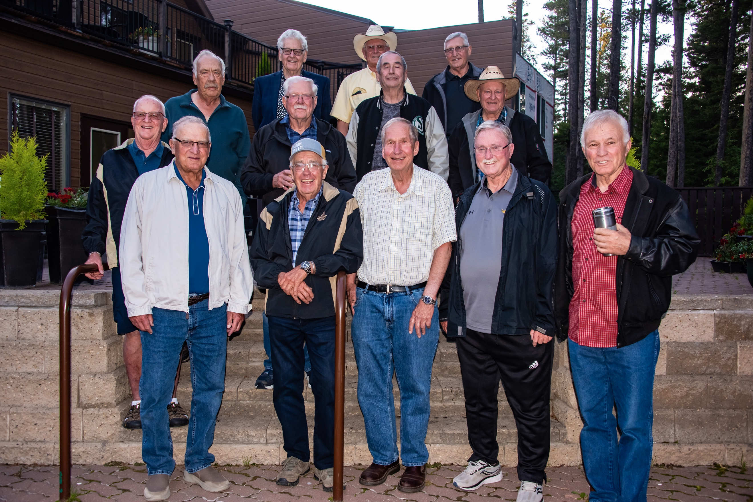

Back Row: Terry Martin, Gordon Stephenson, Jim Sakundiak
Middle Row: Pat Callen, Jim Hammond, Frank Lockwood, Dale Conacher
Front Row: Bryan Drinkle, Alan Hammond, Keith Stolhanske, Dale Pulkinen, Maurice Delage,
Orville Myrvang

June 27 marked the invasion of Cypress Hills by the 69 Agros. It was considerably tamer than it might have been 53 years ago. The afternoon was spent visiting with friends as they arrive.
Dinner was served in the dining room at the Lodge and later we moved to the courtyard of the lodge to continue our evening. Tuesday evening was a barbecue and pot luck and of course a campfire. Wednesday most people were leaving and all were looking forward to getting together again.
I want to thank Gord Stephenson for all the organizing and work he did in making this reunion
such a success.

